


Getting started
with Depot
A guide for everyday use

Contents
How to use this guide
Part 1 · Quick start
1 Signing in
2 Finding your way around
3 Adding files and folders
4 Opening, previewing and editing
5 Keeping things organised
6 Sharing a file
7 Sharing a folder
8 Keeping track of what you've shared
9 Getting notified about files and folders
10 Searching and asking questions
11 Favorites and files shared with you
12 Light or dark: making Depot comfortable
13 What the people you share with see
Part 2 · Going further
14 Meetings and calls
15 Sharing a whole library
16 Groups
17 SharePoint and Windows file shares
18 Depot on your phone

How to use this guide
 | Each chapter shows one everyday task. Most sections have a picture of the screen and numbered steps below it.
 | The orange numbered badges in a picture match the numbered steps. Badge 1 shows where to click for step 1.  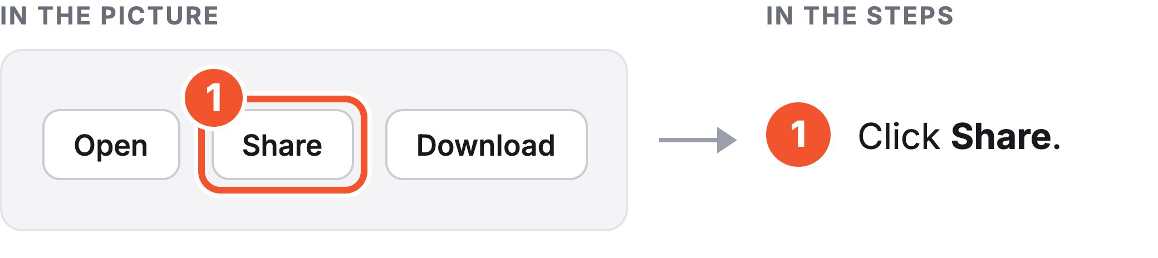
 | Words in bold are labels you see on the screen, such as Share or Upload.
 | Depot has a light look and a dark look. The pictures switch between the two from chapter to chapter, so you will recognise both. Chapter 12, “Light or dark: making Depot comfortable”, shows how to choose.
 | Part 1 covers the everyday basics. Part 2 covers things you will need less often.
 | Whenever you need a chapter fast, turn back to the contents page.

Part 1
Quick start

1 Signing in
2 Finding your way around
3 Adding files and folders
4 Opening, previewing and editing
5 Keeping things organised
6 Sharing a file
7 Sharing a folder
8 Keeping track of what you've shared
9 Getting notified about files and folders
10 Searching and asking questions
11 Favorites and files shared with you
12 Light or dark: making Depot comfortable
13 What the people you share with see

Chapter 1
Signing in
Depot is where your team keeps and shares files. After you sign in, it opens Home, or the file or folder a share email linked to.

The sign-in card
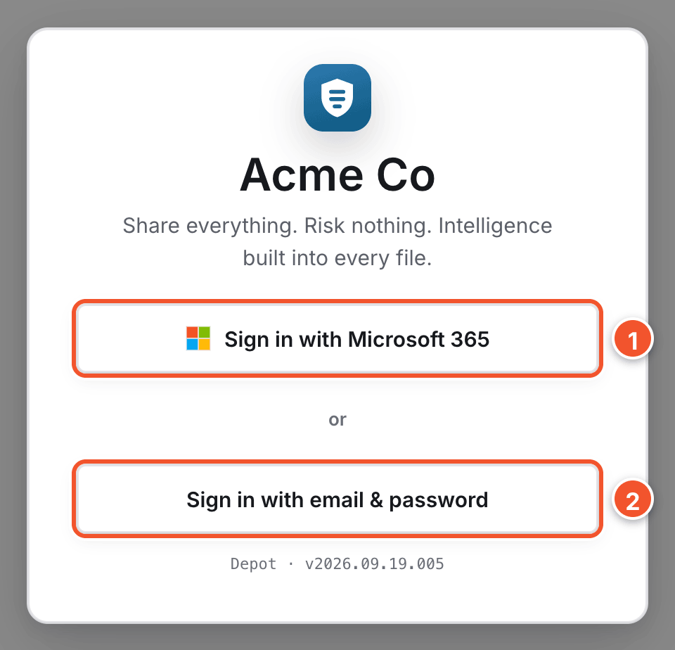
- Click Sign in with Microsoft 365 if your company has turned it on.
- Otherwise, click Sign in with email & password, then type your email and password on the page that opens. If you forget your password, ask your administrator.

Tip
To sign out, click your name in the top right corner, then click Sign out.

Chapter 2
Finding your way around
Every page in Depot has the same top bar and left rail. Home sums up what is happening in your workspace.

The top bar
The search box sits at the left of the top bar.
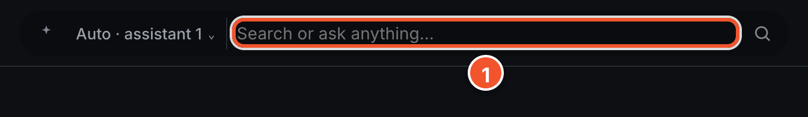
- Click the search box to find files. See “Searching and asking questions”.

The right side of the top bar
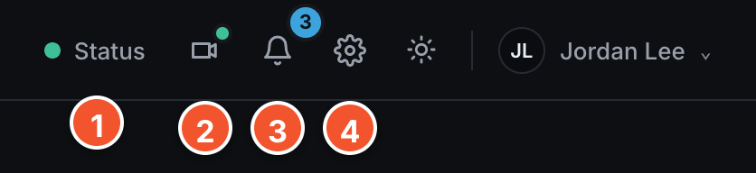
- Click Status to check that Depot is running normally.
- Click the Meetings icon, a video camera, to see who is online and call them.
- Click the bell to see your Notifications.
- Click the gear to open Settings, for your profile, appearance and notifications.
- Click the sun or moon icon to switch between light and dark. See “Light or dark: making Depot comfortable”.
- Click your name, for example Jordan Lee, to open a menu with Sign out.

The left rail
- Home, Files, Favorites, Shared with me, My links and Trash open those pages.
- Files shows the library you have open. A library is a set of files and folders, like a shared drive.
- Click the library name at the top of the rail to switch libraries. Click the star next to one to pin it under Pinned.
- Quick access, further down, lists files you opened recently, newest first.

Home
Home opens when you sign in. Click Home in the left rail to come back to it.
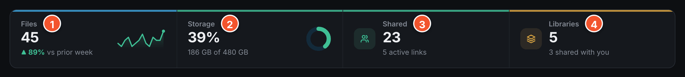
- Files shows how many files you have, and how that is changing.
- Storage shows how much space you are using.
- Shared counts files others added, and your live links.
- Libraries shows how many libraries you can open.

Your libraries
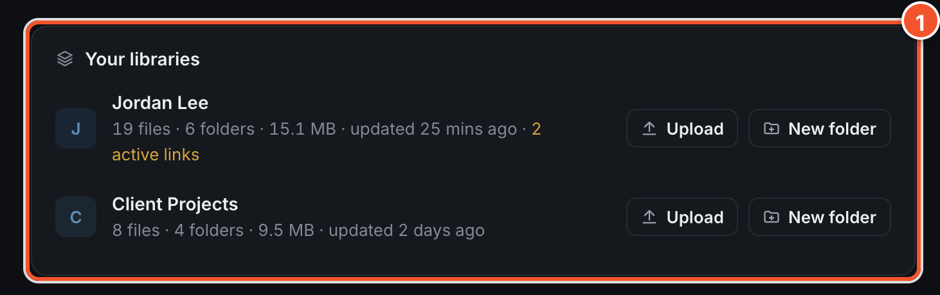
- Your libraries lists your own libraries, with Upload and New folder buttons. Shared with you and Recent files sit below it.

Chapter 3
Adding files and folders
Upload files from your computer, or drag them onto the file list. New files land in the folder you have open.

Upload files or a folder
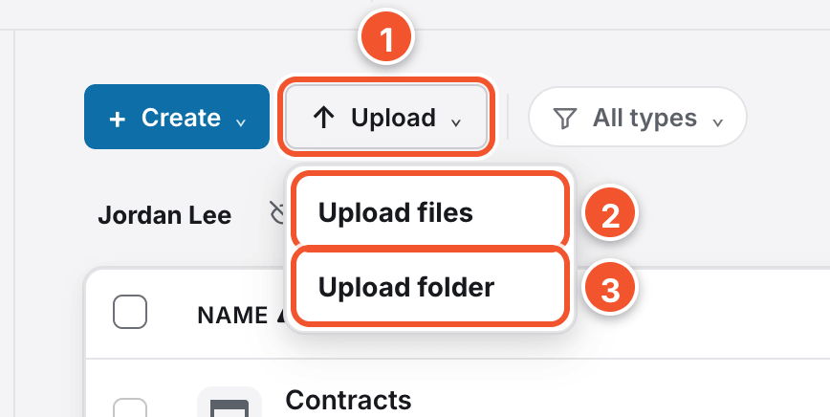
- Click Upload above your files.
- Choose Upload files to add one or more files.
- Choose Upload folder to add a whole folder, with everything inside it.

Create a new file or folder
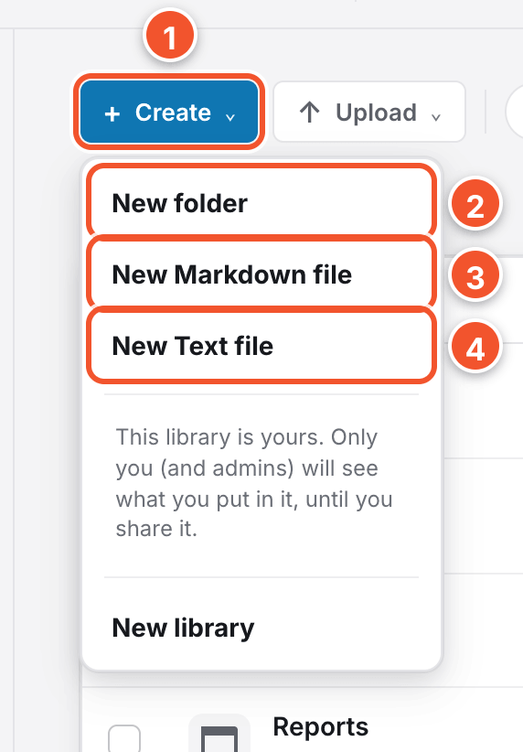 | - Click Create above your files.  - Choose New folder to make a folder.  - Choose New Markdown file for notes with headings and lists.  - Choose New Text file for plain text.
  Tip
  Type a name and click OK. A new file opens straight away, ready to type into.
  Note
  If your company has turned on editing in the browser, the menu also offers New Word document and New Excel spreadsheet. In a library shared with you as read-only, Upload is hidden and Create offers only New library. Ask the owner for Read-Write access.

Chapter 4
Opening, previewing and editing
Click a file's name to look inside it without downloading it. A row of buttons sits above the preview.

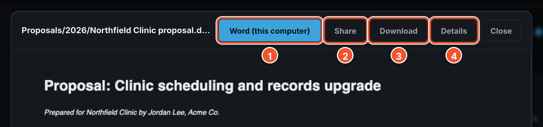
- Click Word (this computer) to open a Word file in Word on your computer and make your changes there. Excel and PowerPoint files get a matching button.
- Click Share to send the file to someone.
- Click Download to save a copy to your computer.
- Click Details to see who added it, when it changed and where it is kept.

Note
If your company has turned on editing in the browser, the first button is Edit instead, and an Open in ⌄ button beside it offers both ways of opening the file.

What you can preview
These files open right inside Depot, without downloading them:
- Pictures, PDFs, videos, audio and saved emails.
- Word documents and Excel spreadsheets.
- Text, Markdown, CSV, JSON and log files, shown with line numbers.

Tip
Click the arrows at the sides of the preview, or press the left or right arrow key, to see the previous or next file.

Chapter 5
Keeping things organised
Folders, filters and Trash keep your files easy to find. To add a folder, see “Adding files and folders”.

Work on several items at once
Select files and folders, and the selection bar appears above the list.
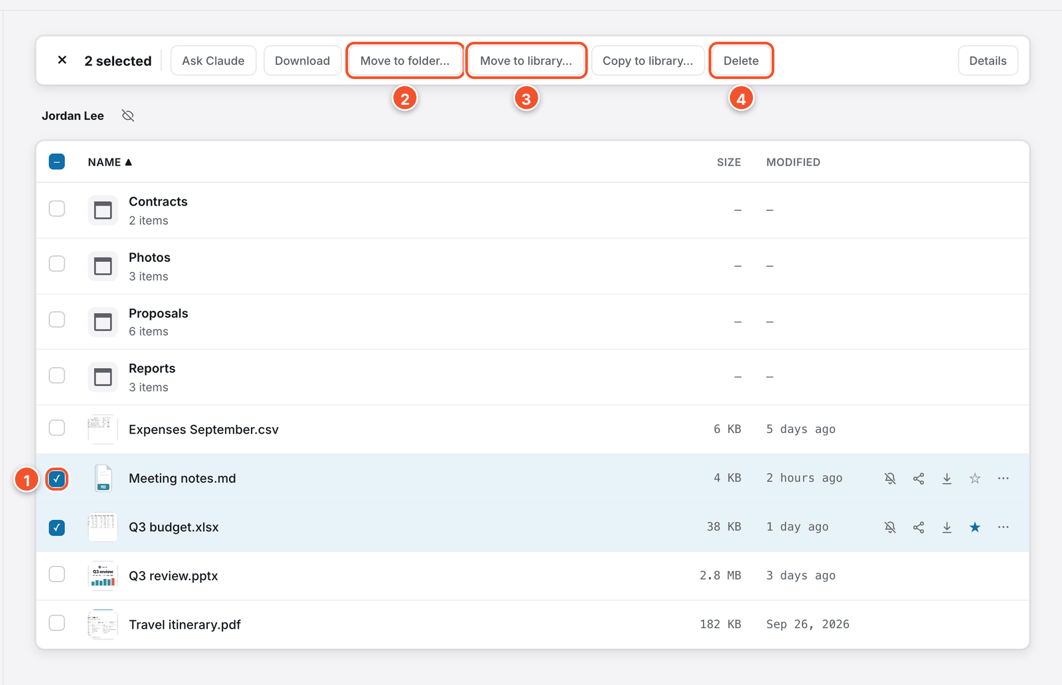
- Click the checkbox at the start of each row you want.
- Click Move to folder…, then click a folder to move everything into it.
- Click Move to library… to move everything you selected to another library.
- Click Delete to move everything you selected to Trash.

Rename or move one item
- Click the three dots at the end of the row.
- Click Rename…, type the new name and click OK.
- The same menu has Move to folder…, and you can also drag a row onto a folder in the list.
- Renaming a folder does not change who it is shared with.

Delete, undo and restore
Deleted files go to Trash, so you can get them back.
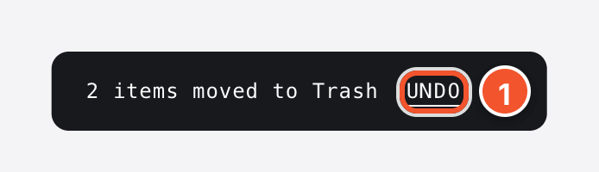
- Click Undo if you change your mind. It stays until you close it or Depot shows another message.
- Later, click Trash in the left rail. The page is called Recycle bin.
- Click Restore next to the file you want back.

Note
Deleting a folder asks you to confirm first, because it can end sharing on that folder.

Filter, sort and change the view
- Click All types and choose a type, such as Images, to show only those files.
- Click Name, Size or Modified at the top of the list to sort by it. Click again to reverse it.
- Drag the slider next to Details to the right for tiles, or to the left for a list.

Chapter 6
Sharing a file
Share turns a file into a link, or an invite to the people you name. You choose who gets it, what they can do and how long it lasts.

Choose who gets it and what they can do
Click Share on a file's row, or in the bar above its preview.
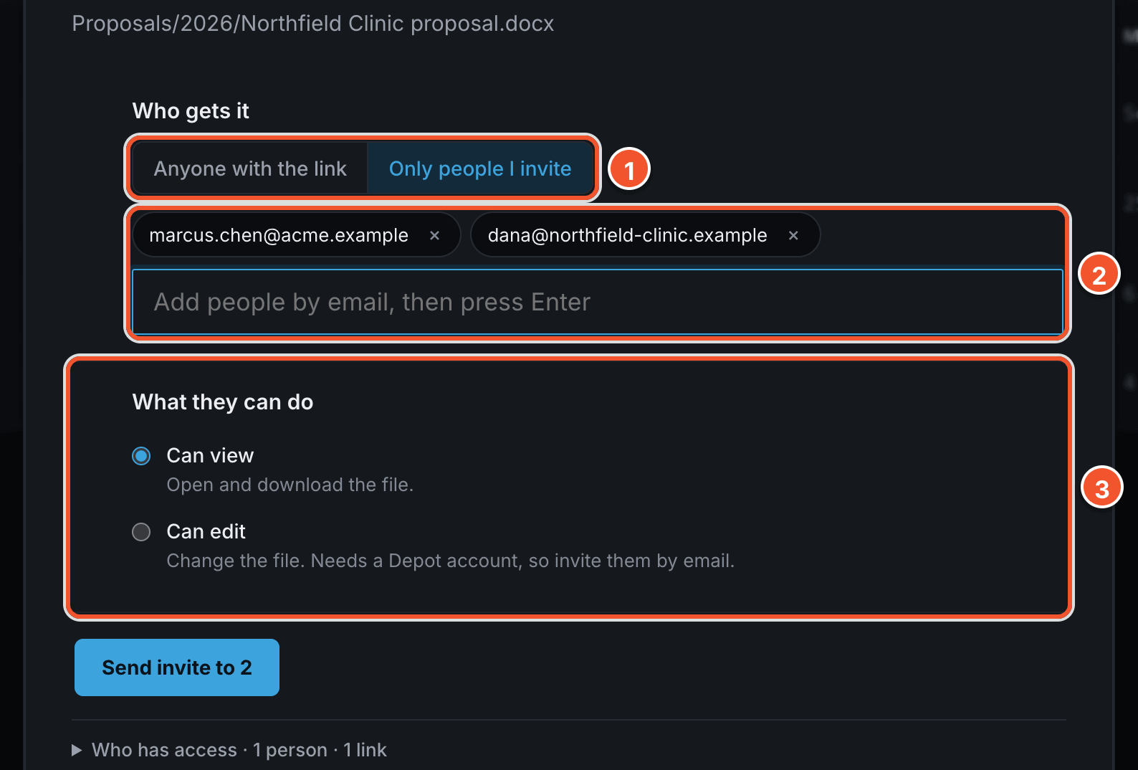
- Under Who gets it, choose Anyone with the link or Only people I invite.
- If you invite people, type each email address and press Enter.
- Under What they can do, choose Can view or Can edit. Can edit is for people you invite.

Set how long it lasts and how locked it is
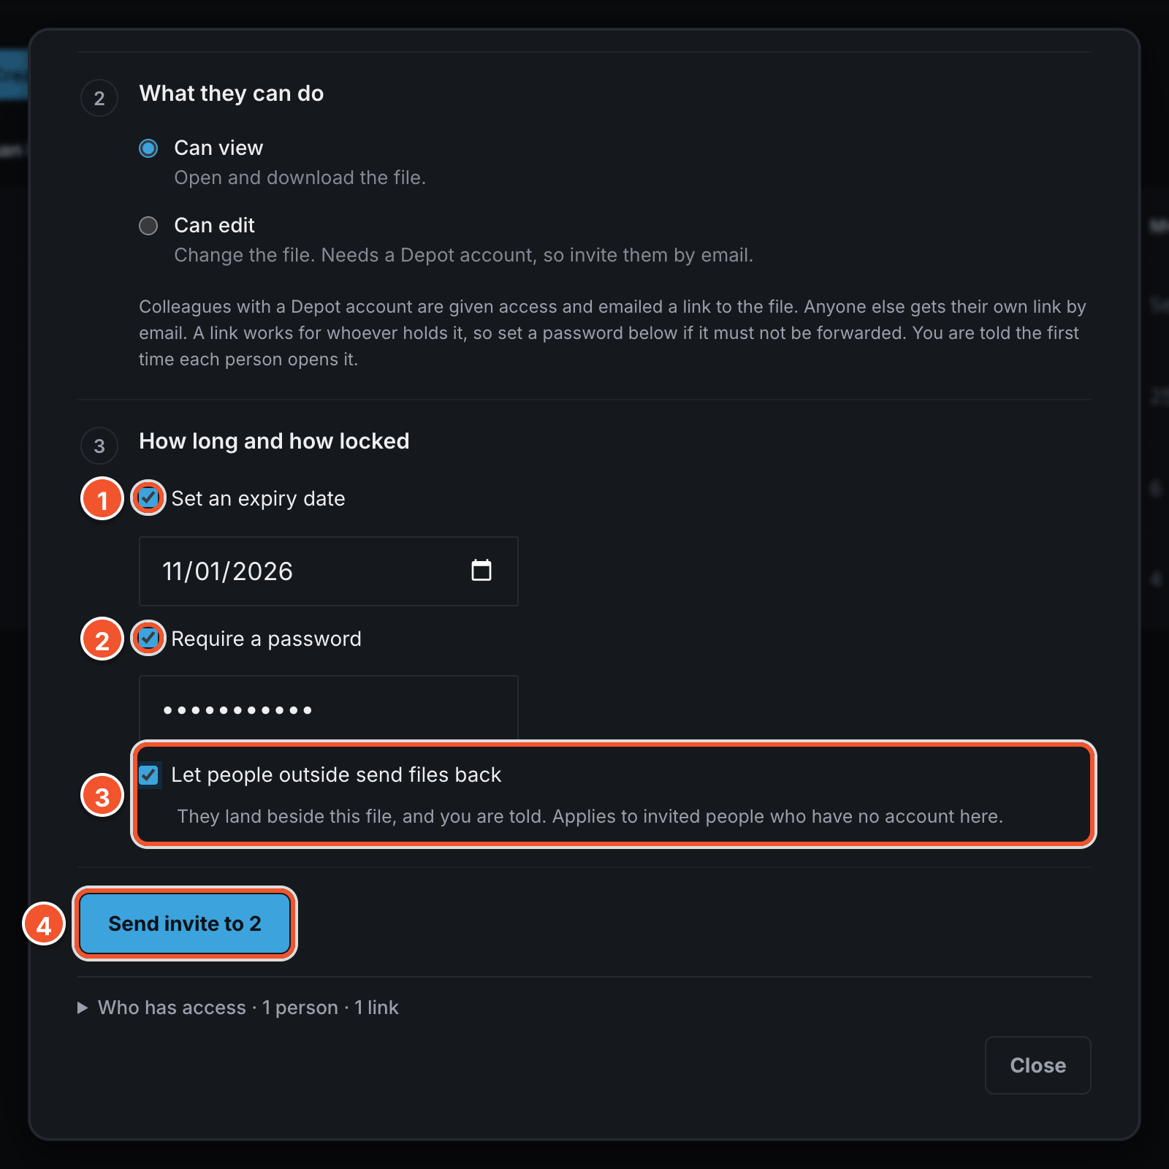
- Turn on Set an expiry date to choose when it stops working.
- Turn on Require a password so only people who know it can open the file.
- Turn on Let people outside send files back if you want the people you invited to send files to you.
- Click Create link to copy a link, or Send invite to email the people you added.

Note
A link with no expiry date never expires. An invite with no expiry date expires after 30 days.

What the people you invite receive
- A colleague with a Depot account gets an email with a link. If you can give them access, the file also appears in their Shared with me. If not, the link opens a view-only copy, only for them, once they sign in.
- Anyone else, such as people outside Acme, gets a link of their own by email. If the email cannot be sent, Depot shows you the link to pass on.
- A password only protects links for people outside Acme. Colleagues sign in instead. To see the page people outside Acme open, turn to “What the people you share with see”.
- If you can only view a file yourself, you cannot create a link to it or let others edit it.

See who has access, and revoke it
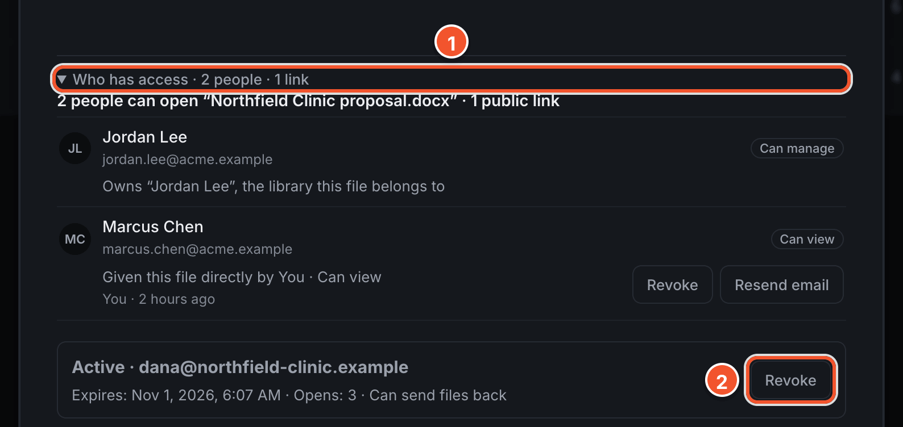
- Click Who has access to see everyone who can open the file, and any links you have made.
- Click Revoke next to a person or a link to take away their access.

Chapter 7
Sharing a folder
Share a folder when someone needs more than one file. Create a link anyone can open, or send it to named people.

Open the folder's Share window
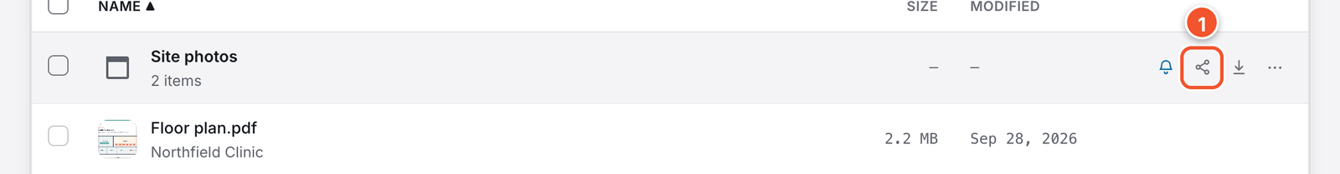
- Point to the folder, then click the Share icon on its row.

Tip
You can also click the folder's checkbox, then click Share in the selection bar.

Note
If you own or manage the library, the window also has People and groups at the top. It works the same way as in “Sharing a whole library”.

Create a link anyone can open
Use Anyone with the link for one link to hand around. It only shows the files in the folder right now, not ones you add later.
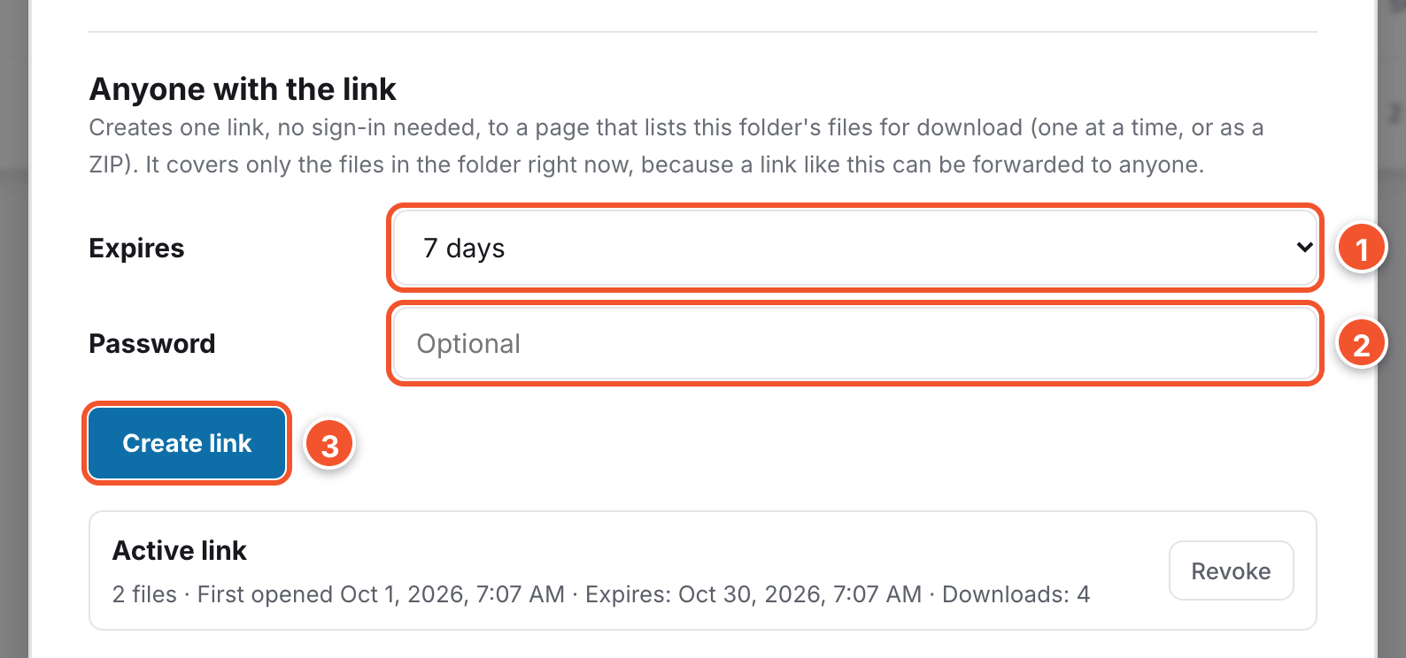
- Under Anyone with the link, choose how long it lasts under Expires.
- Add a Password if you want one.
- Click Create link. Depot copies the link so you can paste it anywhere.

Send it to named people
Use Send to people when you know who needs the folder. They always see its newest files, including ones you add later.
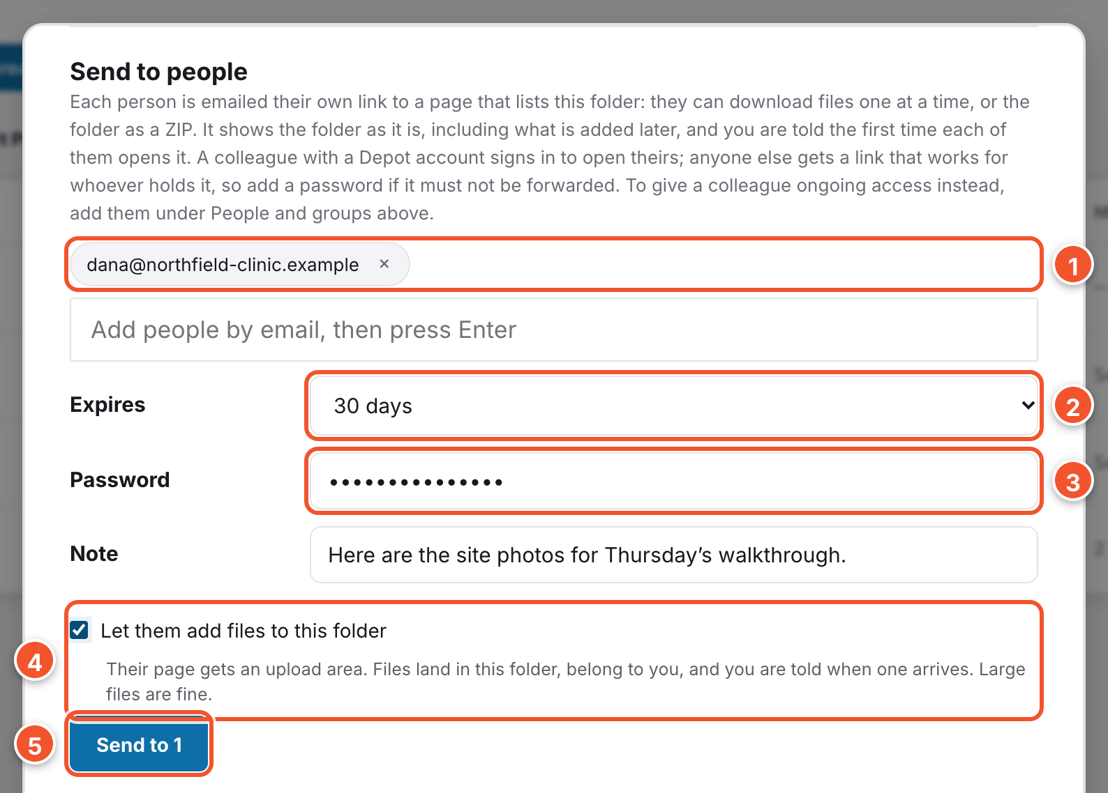
- Under Send to people, type each email address and press Enter.
- Under Expires, choose how long the link should work.
- Add a Password if the files are sensitive, and a Note to say why you sent them.
- Turn on Let them add files to this folder if they should send files back.
- Click Send to 1. The number is how many people you added.

Note
Colleagues sign in to open the folder. Anyone else can open the link without signing in, so add a password if it must not be passed on. To stop any folder link working, click Revoke next to it in this window.

Chapter 8
Keeping track of what you've shared
My links keeps a record of every link you have made, from any file or folder, whether it still works or not.

See your links
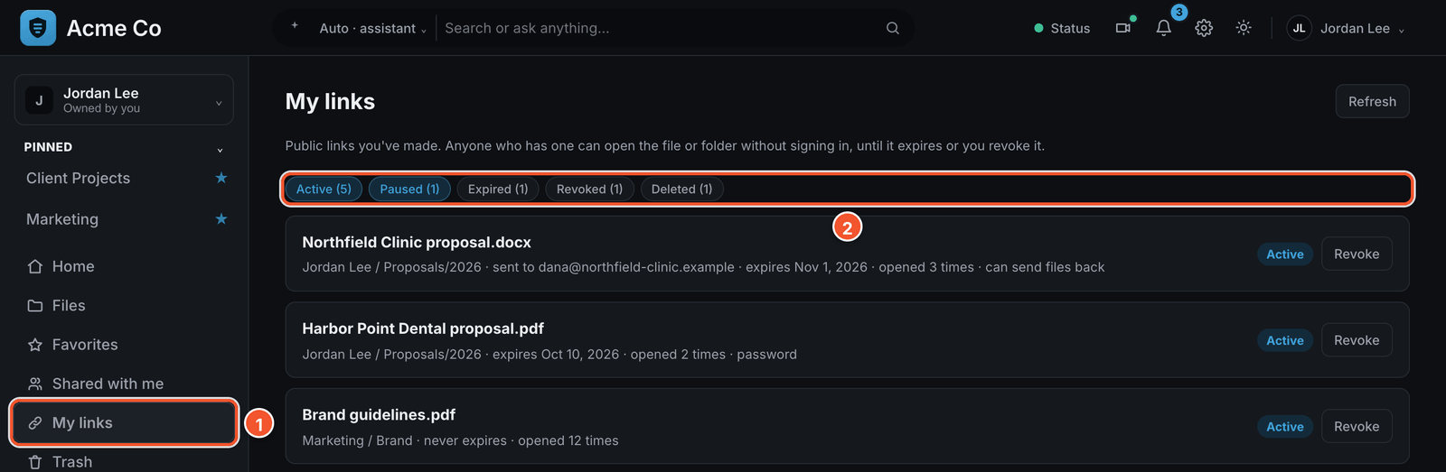
- Click My links in the left rail.
- Click the chips above the list to show or hide links by status.
- Active links work right now.
- Paused links will not open, because you lost the right to edit the file or folder. The card explains why.
- Expired links have passed their expiry date.
- Revoked links are ones you turned off.
- Deleted links point to a file or folder that no longer exists.

Tip
Each card shows who the link was sent to and when it expires. It also shows how often it was opened, and whether it needs a password.

Revoke a link
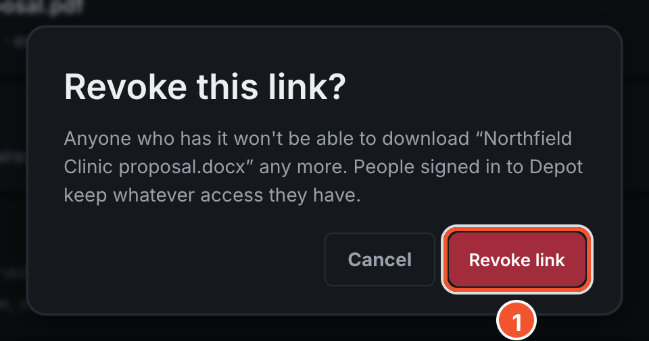
- Click Revoke on the link's card, then click Revoke link to confirm.

Note
Nobody can use the link after that. Colleagues who already had access in Depot keep it.

Keep an eye on links from Home
- The Links you sent card on Home lists your newest links, and whether each has been opened.
- A bar above your libraries on Home warns you when a link expires within a week.

Chapter 9
Getting notified about files and folders
Depot tells you when the files and folders you care about change. You choose what it tells you about.

Follow a file
Every file has its own bell. Point to a file's row to show it.
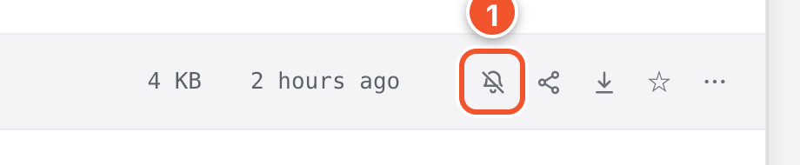
- Click the bell icon, Follow this file for updates. The bell loses its slash and turns blue.

Tip
Depot now tells you when someone downloads the file from a link. If your company has turned on editing in the browser, it also tells you when someone edits it.

See everything in the bell
Click the bell in the top bar to open Notifications. The newest notices are at the top.
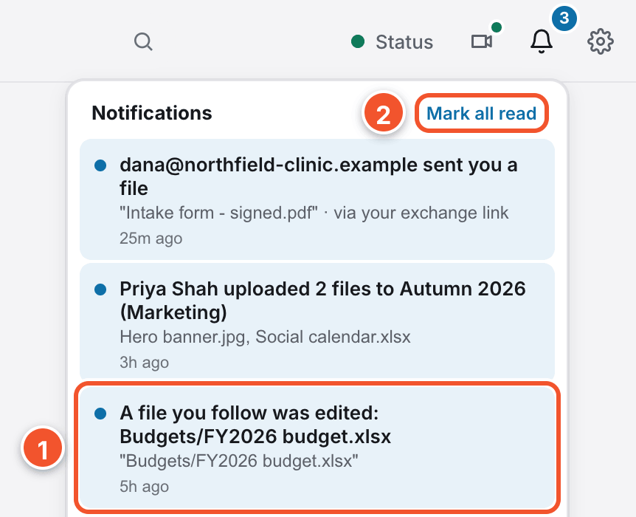
- Click a notice to jump straight to the file or folder.
- Click Mark all read to clear every unread dot.
- Notices tell you when someone opens or downloads something you shared, or sends files back to you.
- They also tell you when you are given access to something.

Hear about new files in a folder
Folders you own already tell you when a new file lands in them. You do not need to turn this on.
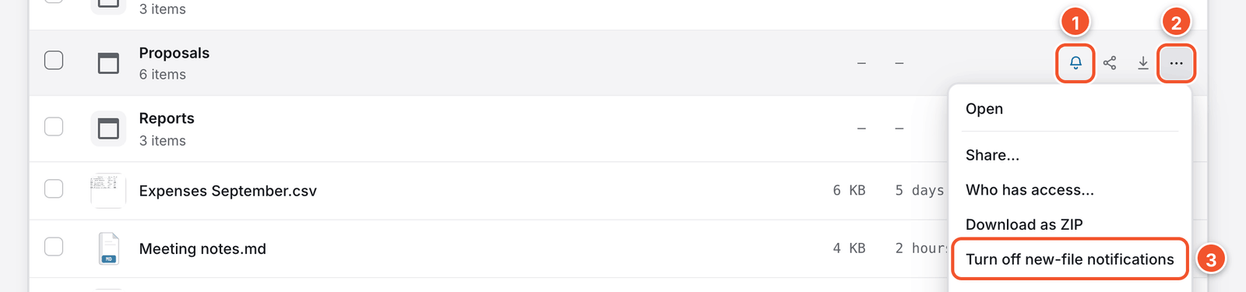
- Point to one of your folders. Its bell icon is already blue, with no slash through it.
- Click the three dots at the end of the folder's row.
- Click Turn off new-file notifications to stop. Anyone the folder is shared with can do the same for themselves.

Choose what the bell does
Click the gear in the top bar, then click Notifications.
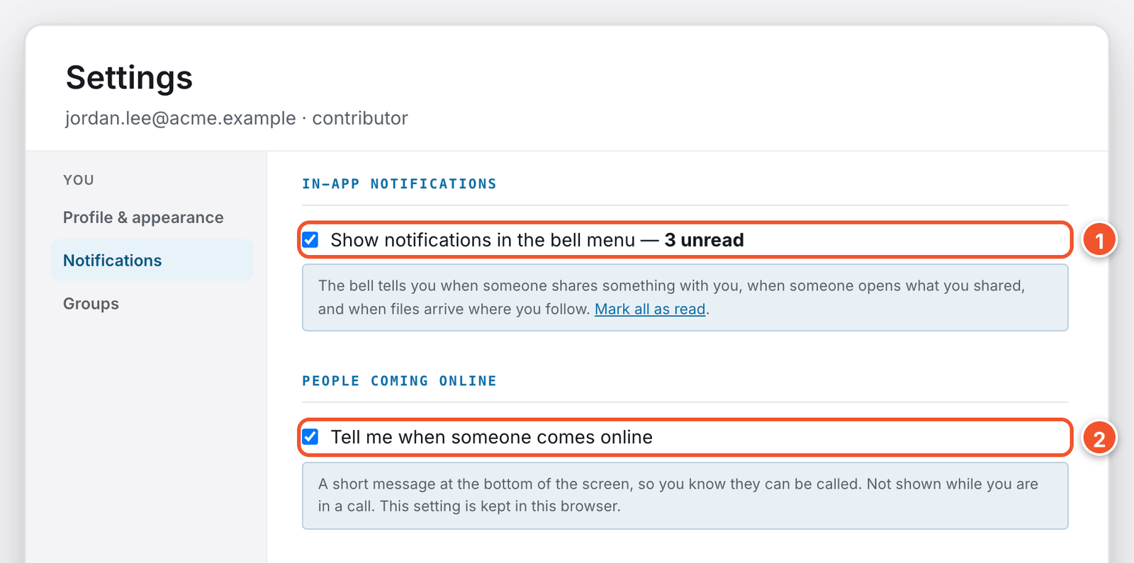
- Turn off Show notifications in the bell menu to stop notices in the bell.
- Turn off Tell me when someone comes online to stop those messages.

Get notices by email
Depot can also email you, so you hear about things even when Depot is not open. The email has a link straight to the file or folder.
To see which notices you get by email, click the gear in the top bar, then Notifications. Look under Email notifications.
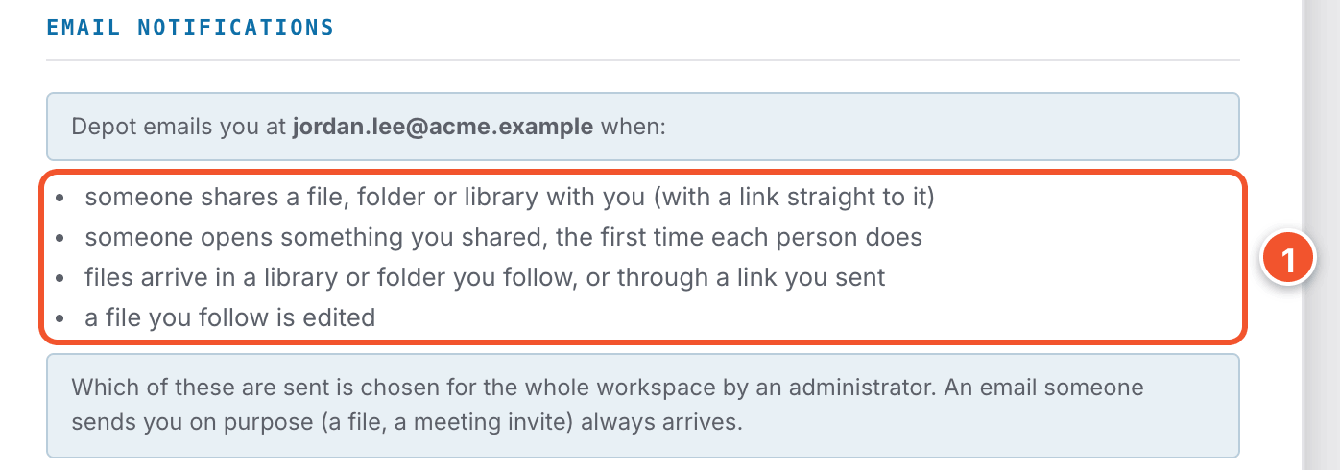
- This list shows every notice Depot emails to you, and the address it uses.
- Someone shares a file, folder or library with you.
- Someone opens something you shared, the first time each person does.
- Files arrive in a library or folder you follow, or through a link you sent.
- A file you follow is edited in the browser, if your company has turned that on.

Note
Your administrator chooses which emails everyone at your company gets. If the page says email isn't set up yet, ask your administrator to turn it on.

Chapter 10
Searching and asking questions
The search box in the top bar finds files by name or by what is inside them. If your company has turned on AI, you can also ask questions.

Search for a file
Click the search box and type a word or a file name. Depot lists matches as you type, even when the word is only inside a file.

Choose what you search
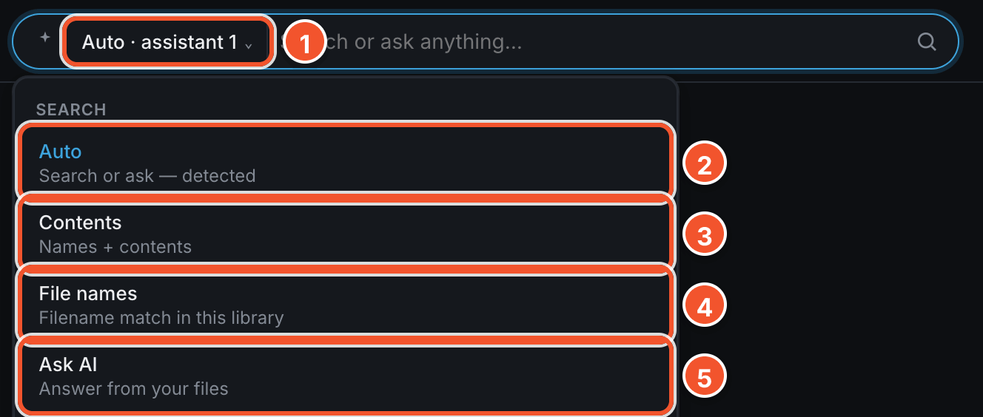
- Click the button next to the search box. It starts with Auto.
- Choose Auto to search names and contents, or answer a question.
- Choose Contents to search file names and what is inside files.
- Choose File names to match file names only.
- Choose Ask AI to treat everything you type as a question.

Ask a question
Type a full question in the search box and press Enter. For example: What does the Northfield Clinic proposal cost? A window called Ask the collection opens.
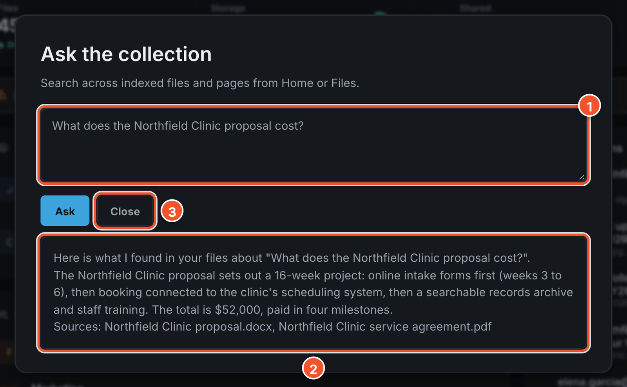
- Your question appears at the top.
- The answer appears underneath. It only uses files you are allowed to open.
- Click Close when you are done.

Ask about particular files
- Select the files you want to ask about.
- Click the Ask Claude button in the selection bar. You can also right-click a file and choose Ask AI about this.
- Type your question, then click Ask Claude. The answer only uses the files you chose.

Chapter 11
Favorites and files shared with you
Star the files you use most. Find what other people have shared with you.

See what other people have shared with you
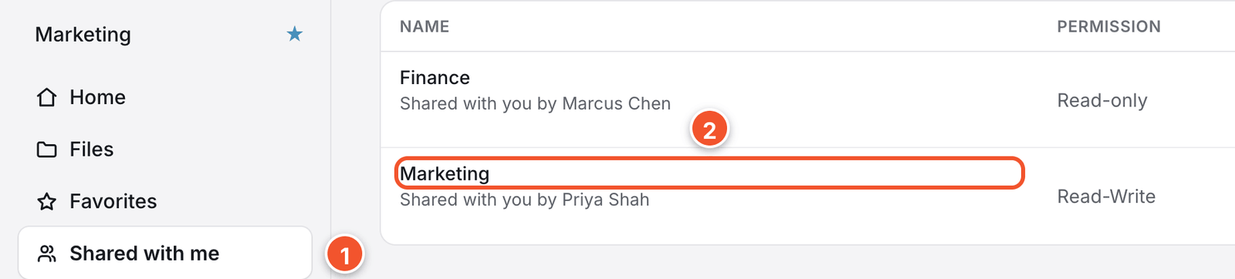
- Click Shared with me in the left rail.
- Click any row to open it where it lives. The Permission column shows what you can do there.

Star a file
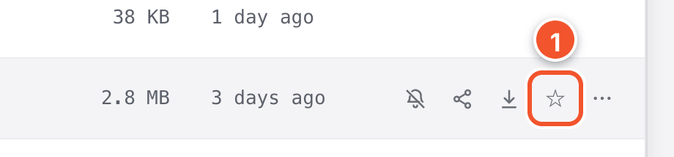
- Point to a file and click the star on its row. The star turns solid.
- Click Favorites in the left rail to see your starred files in this library.

Chapter 12
Light or dark: making Depot comfortable
Click the sun or moon icon in the top bar to switch light and dark.

The quick way
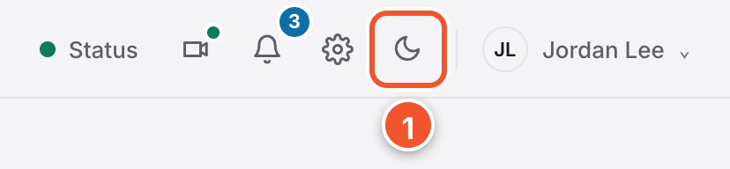
- Click the sun or moon icon at the right of the top bar. Depot switches right away.

More choices in Settings
Click the gear in the top bar. Settings opens on Profile & appearance.
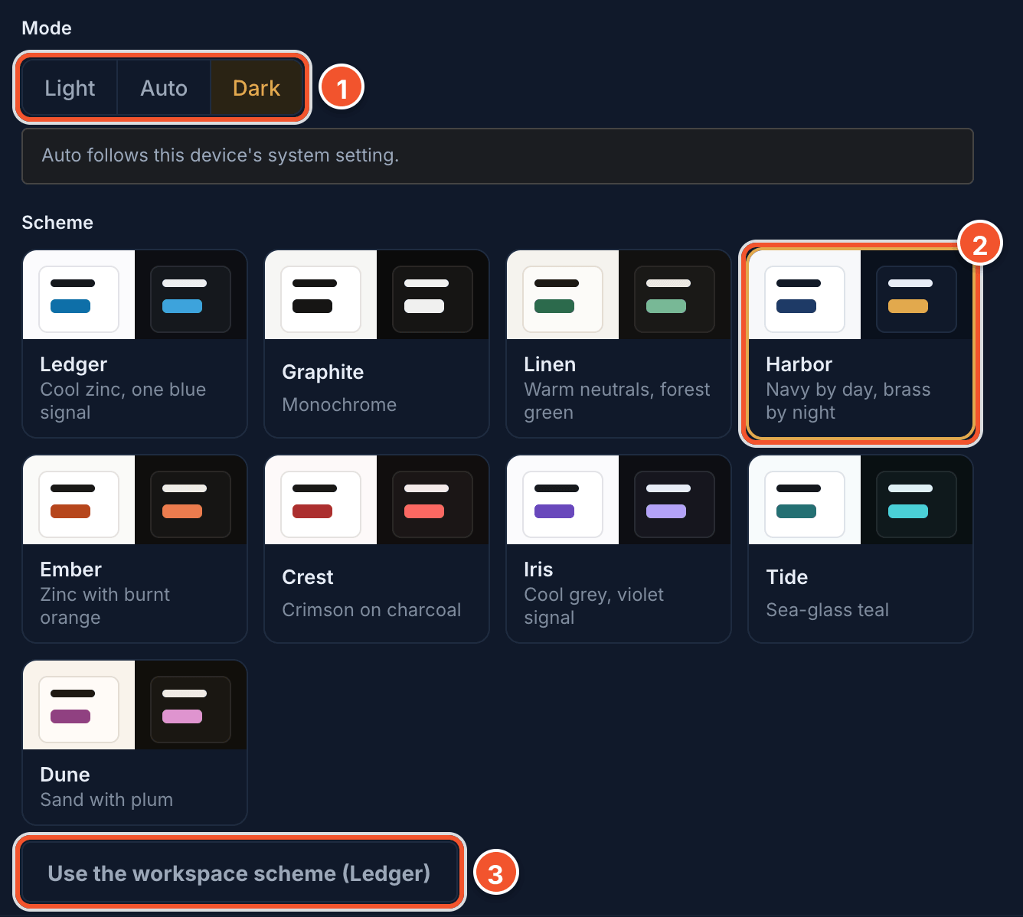
- Under Mode, click Light, Auto or Dark. Auto follows your computer.
- Click a colour card under Scheme to use it on this device.
- Click Use the workspace scheme to go back to your company's colours.

Tip
On the same page, click Upload photo to add your picture, type your name in Full name, then click Save profile.

Chapter 13
What the people you share with see
People outside Acme do not sign in to Depot. Your link opens a plain page with only what you sent them. You can pass these steps on if they need help.

A shared file
The page shows the file's name and size, who sent it and when the link stops working.
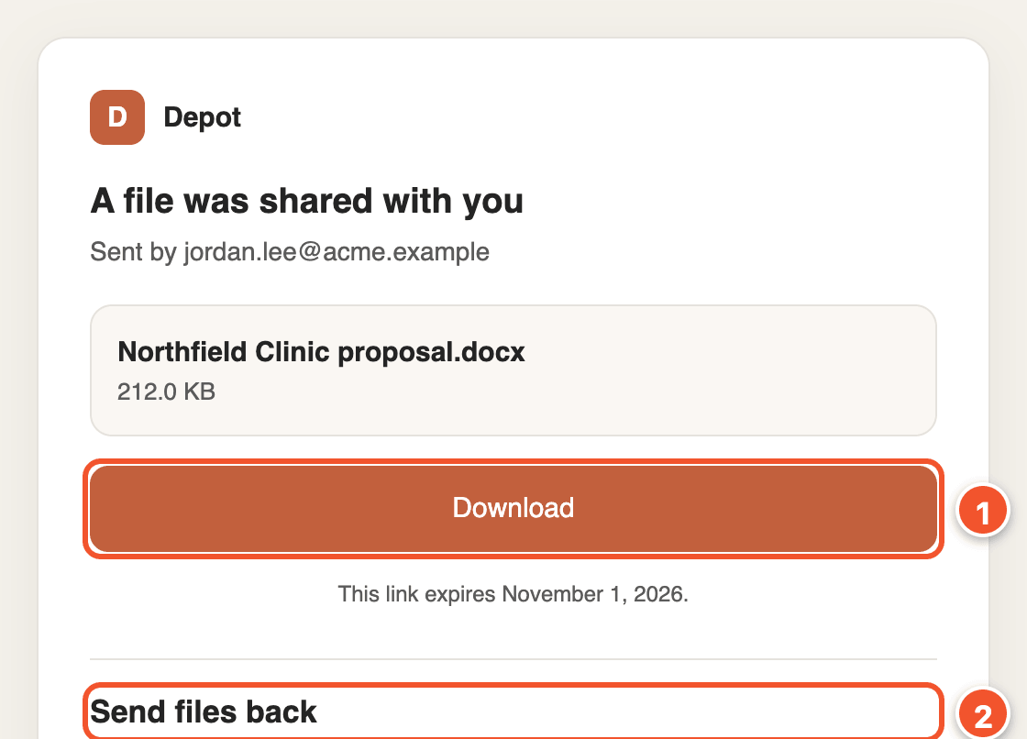
- They click Download to save the file.
- If you let them send files back, they use Send files back to send files to you.

Note
If you set a password, the page asks for it first. They type it in the Password box and click Unlock. Give them the password another way, such as by phone.

A shared folder
A folder page lets them look inside first. Subfolders show up in the list, alongside the files.
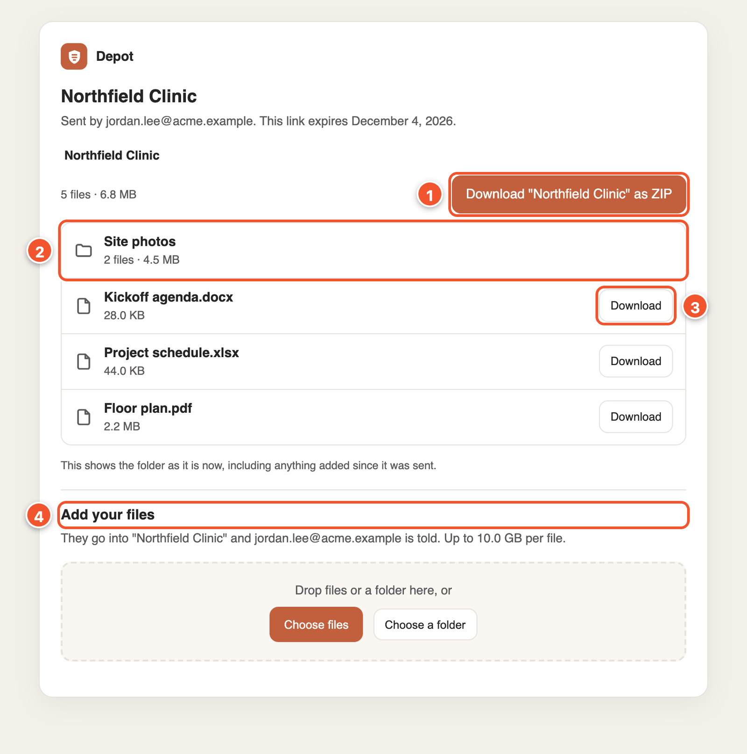
- They click Download "Northfield Clinic" as ZIP to get every file at once.
- They click a folder in the list to open it.
- They click Download next to a file to get only that one.
- If you let them add files, they use Add your files to send files into the folder.

Note
A folder you sent to named people shows new files as you add them. A link anyone can open only shows what was there when you made it.

When a link stops working
An expired or revoked file link opens a page headed Link unavailable. The line under it says why, such as This link has expired.
A folder link that no longer works shows This link isn't available instead.
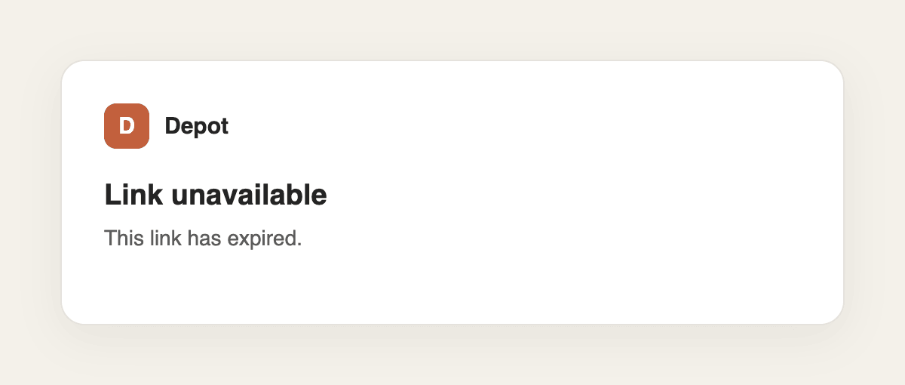

Tip
If they still need the file, create a new link and send it to them.

Part 2
Going further

14 Meetings and calls
15 Sharing a whole library
16 Groups
17 SharePoint and Windows file shares
18 Depot on your phone

Chapter 14
Meetings and calls
Call a colleague, start a call anyone can join, or schedule one for later. Everything starts from the Meetings icon in the top bar.

See who is online, and start a call
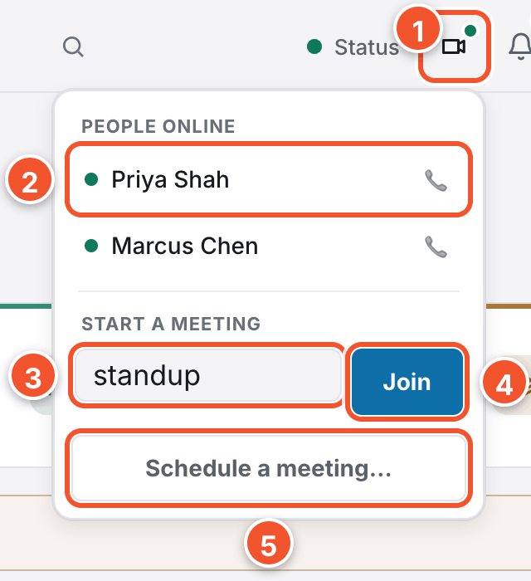
- Click the Meetings icon. A green dot means someone else is online.
- Under People online, click a name to call that person.
- Type a room name under Start a meeting to start a group call.
- Click Join. Anyone who joins the same room name joins the same call.
- Click Schedule a meeting… to set up a call for later.

Schedule a meeting for later
Fill in the Title, Date, Time and Minutes. Under Attendees, type email addresses separated by commas. Then click Send invites to email everyone, or Copy invite to copy a join link.

Note
Everyone who joins needs a Depot account and must sign in.

Answer a call
When someone calls you, Depot shows their name. Click Accept to join, or Decline if you cannot talk.

In a call
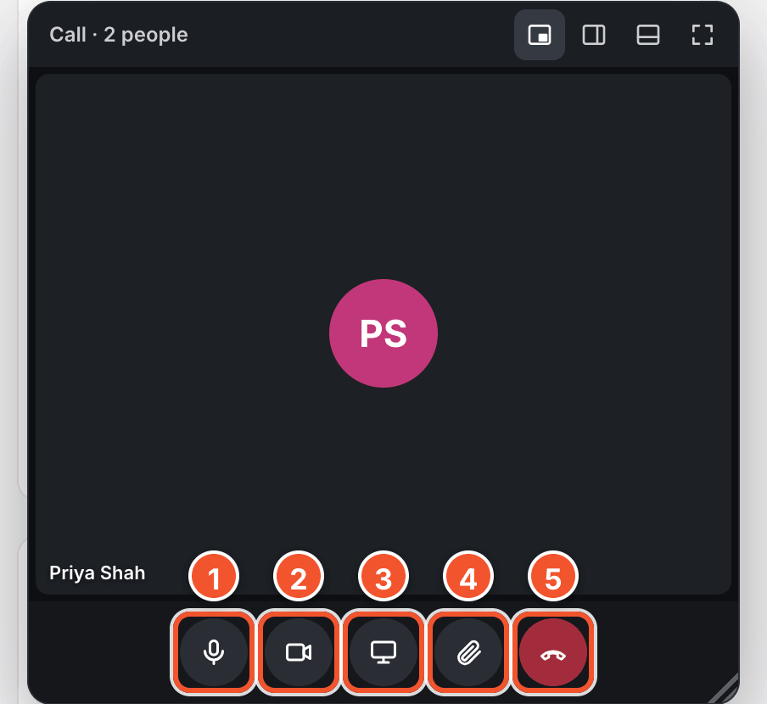
- Click Mute to turn your microphone off or on.
- Click Turn camera off to stop or start your video.
- Click Share screen to show everyone your screen.
- Click Send a file to send a file to everyone on the call.
- Click Leave call when you are finished.

Chapter 15
Sharing a whole library
Share a whole library when several people need lasting access to everything in it, including files added later. You can share libraries you own or manage.

Open a library's Share window
Open the library switcher at the top of the left rail.
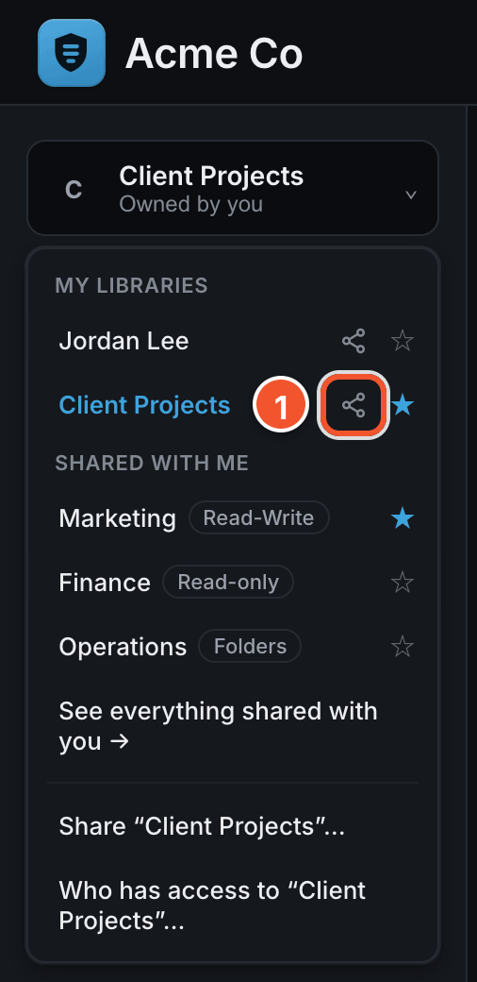 | - Click the Share icon next to a library you own.
  Tip
  For the library you are in, you can also click Share “Client Projects”… at the bottom of the list.
  Note
  A library you do not manage shows Your access to “Finance”… instead. It tells you how you can get in, but does not let you change anything.

Share it with a person or a group
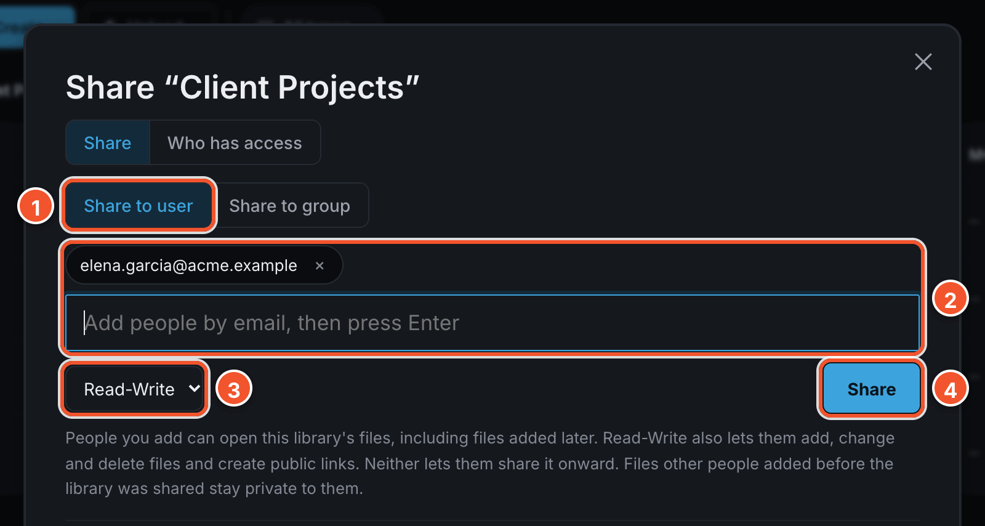
- Click Share to user to add a person, or Share to group to add a whole team.
- Type an email address and press Enter, or choose a group from the list.
- Choose Read-Write or Read-only.
- Click Share.
- Read-Write lets someone add, change and delete files, and create links to send things to people outside Acme.
- Read-only lets someone open and download files, but not change anything.
- To change someone's level, choose a new one from the dropdown next to their name. Click Remove to take away their access.

Note
Neither level lets someone add other people. Only you or your administrator can do that. Files someone added before you shared the library stay private to them.

See everyone who has access
Click Who has access at the top of the window. It lists everyone who can open the library, however they got in, including through a group.
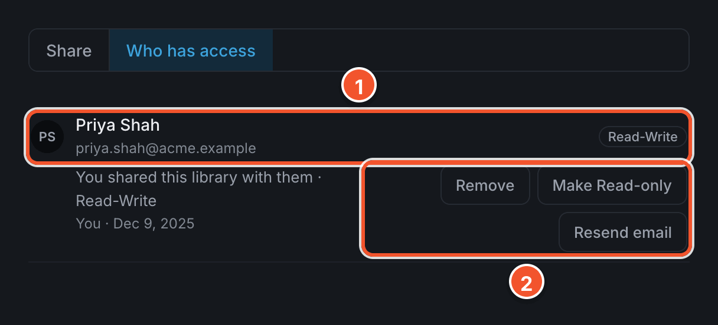
- Click a person's name to see how they can get in.
- Click Remove, Make Read-only or Resend email.
- Links to files or folders in this library show here too, under Anyone with a link, each with its own Revoke button.
- People who have not signed in to Depot yet show under Waiting. They get in once they sign in with that email address.

Create a library of your own
- Open the library switcher and click ＋ New library at the bottom of the list.
- Type a name for the library.
- Click Create library.

Note
A new library is private until you share it. Only you and your administrator can see it.

Chapter 16
Groups
A group lets you share with a whole team in one step. A group can include people outside Acme.

Create a group
Click the gear in the top bar, then Groups.
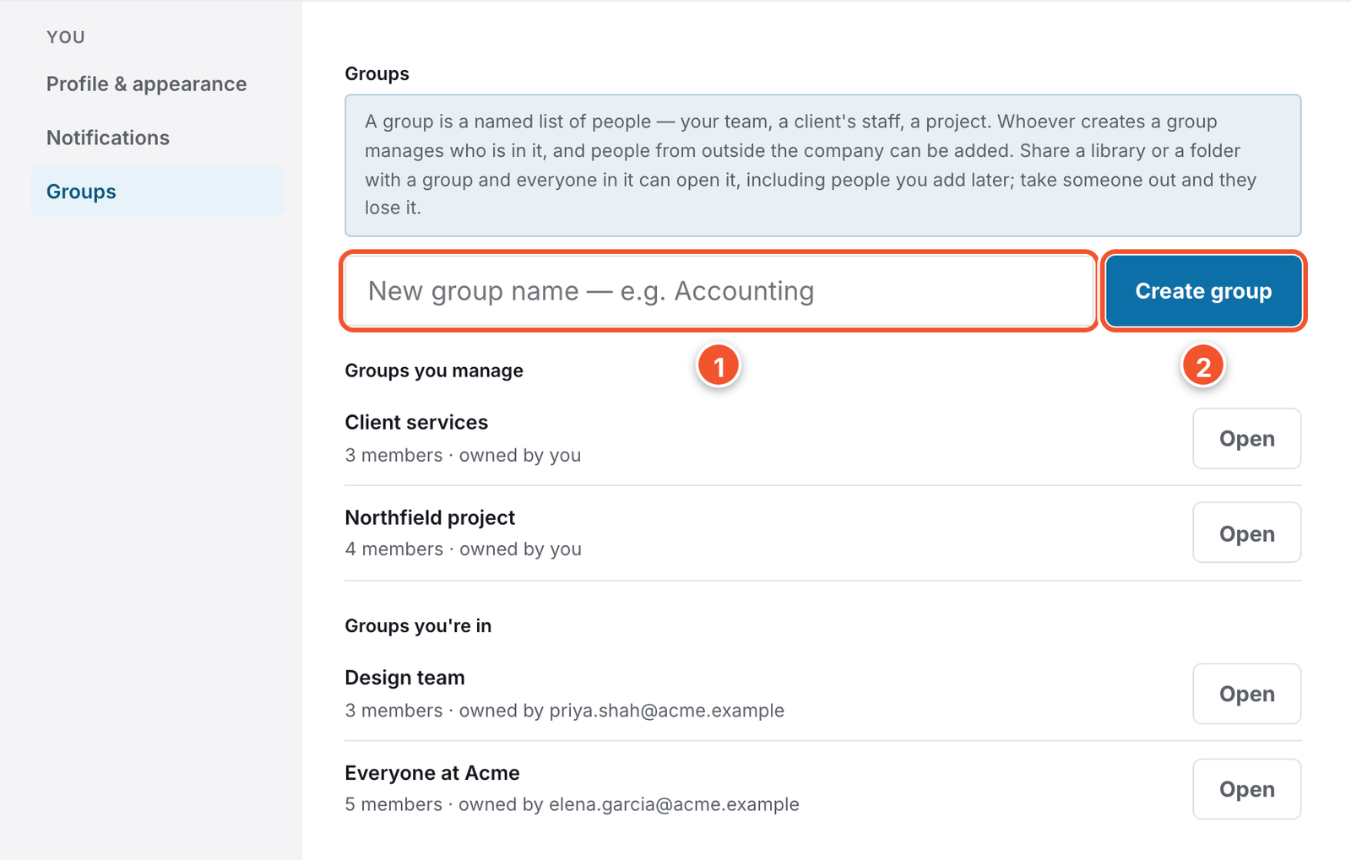
- Type a name in the New group name box.
- Click Create group.

Add or remove members
Click Open next to a group to see who is in it.
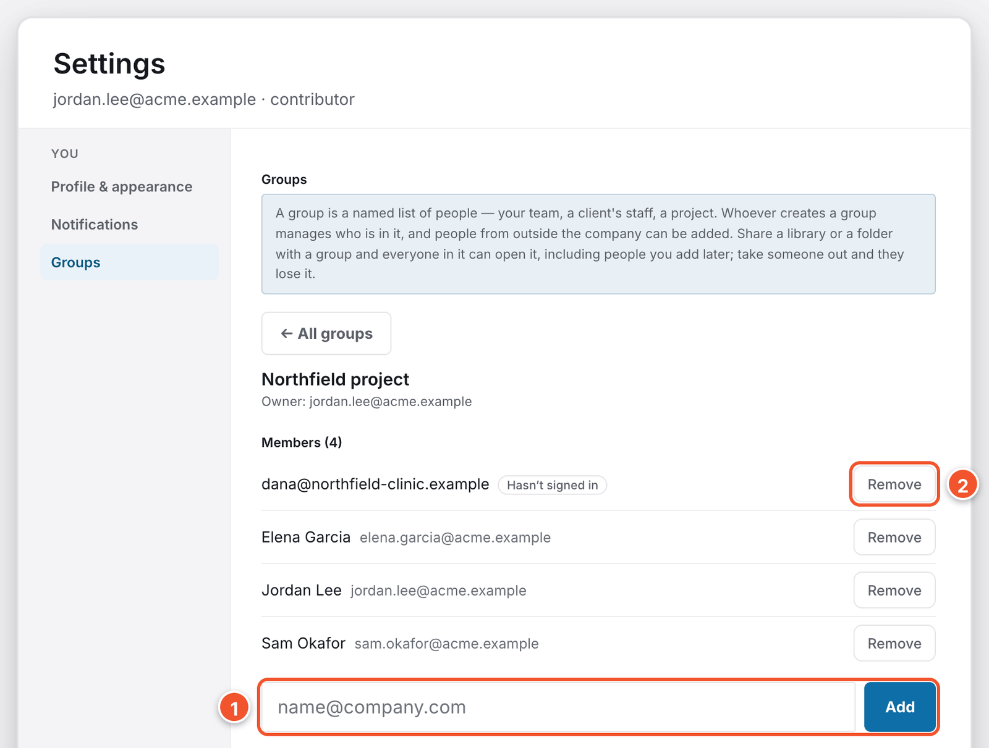
- Type an email address in the box, then click Add.
- Click Remove next to someone to take them out. Only the group's owner, or your administrator, can change a group.
- Choose Share to group when you share a library or folder. See “Sharing a whole library”. People you add to the group later get the same access.

Chapter 17
SharePoint and Windows file shares
If your company has connected SharePoint or a Windows file share, you can browse it from Depot. Files stay where they are.

Open a connection
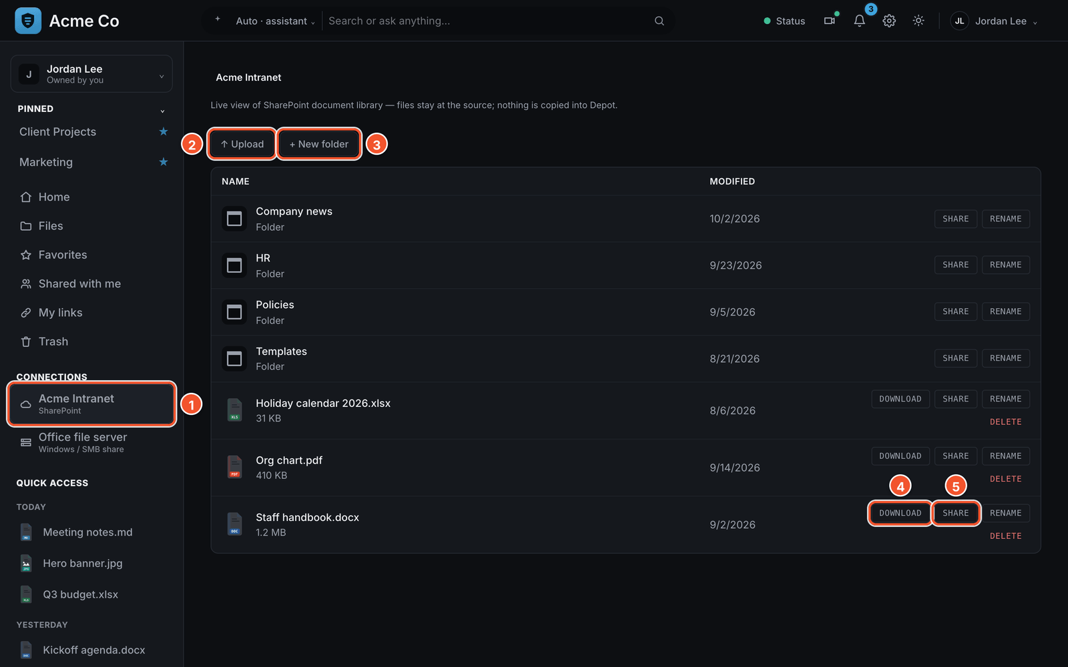
- Click a name under Connections, near the bottom of the left rail.
- Click Upload to add files from your computer.
- Click New folder to add a folder here.
- Click Download on a file's row to save a copy.
- Click Share on a SharePoint file's row to see your sharing options.
- Click Rename or Delete on a file's row to rename or remove it.
- Click a SharePoint file's name to open it in Microsoft 365.
- Windows file shares have no Share button.

Share a SharePoint file
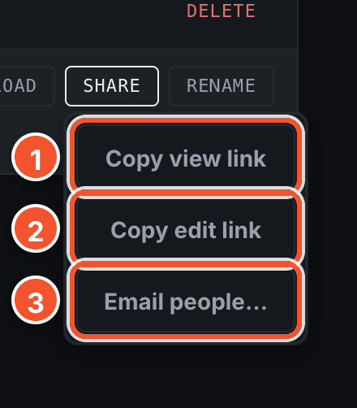
- Click Copy view link to copy a link anyone can open.
- Click Copy edit link to copy a link people can also change.
- Click Email people… to send it to named people by email.

Unlock a personal Windows share
Some Windows file shares ask for your own network sign-in the first time, so you see only what your account allows.
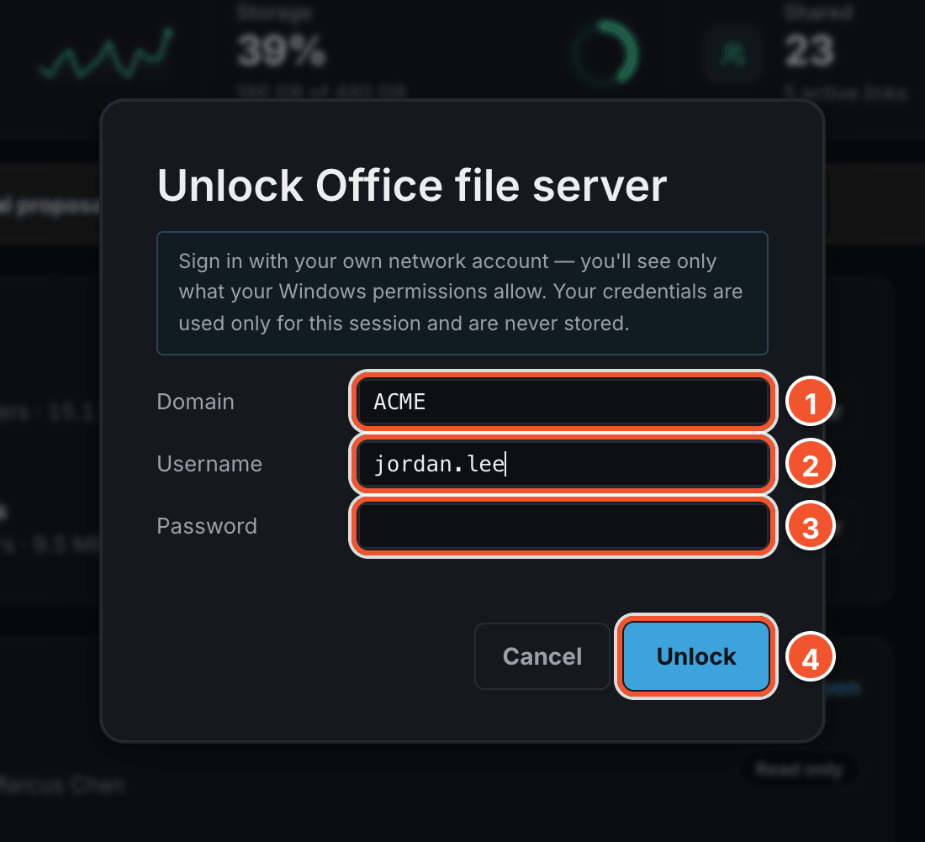
- Type your Domain.
- Type your Username.
- Type your Password.
- Click Unlock.

Note
Depot uses your sign-in only for this session, and never saves it. On a shared computer, click Lock at the top of the share to make Depot forget it straight away.

Chapter 18
Depot on your phone
Open Depot in your phone's web browser and sign in as usual. The screen rearranges itself to fit.

Home on a phone
The left rail becomes a row of buttons under the search box. Swipe it sideways to see them all.
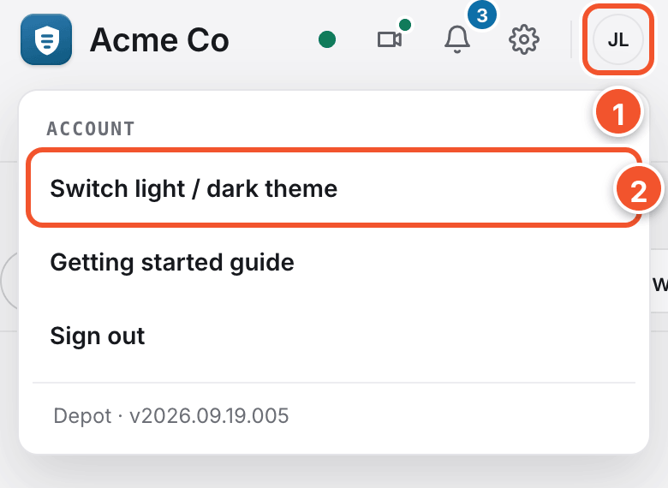
- Tap your initials in the top right corner to open your account menu.
- Tap Switch light / dark theme to change how Depot looks.

Add a photo
Tap Files in the row of buttons under the search box to see your files.
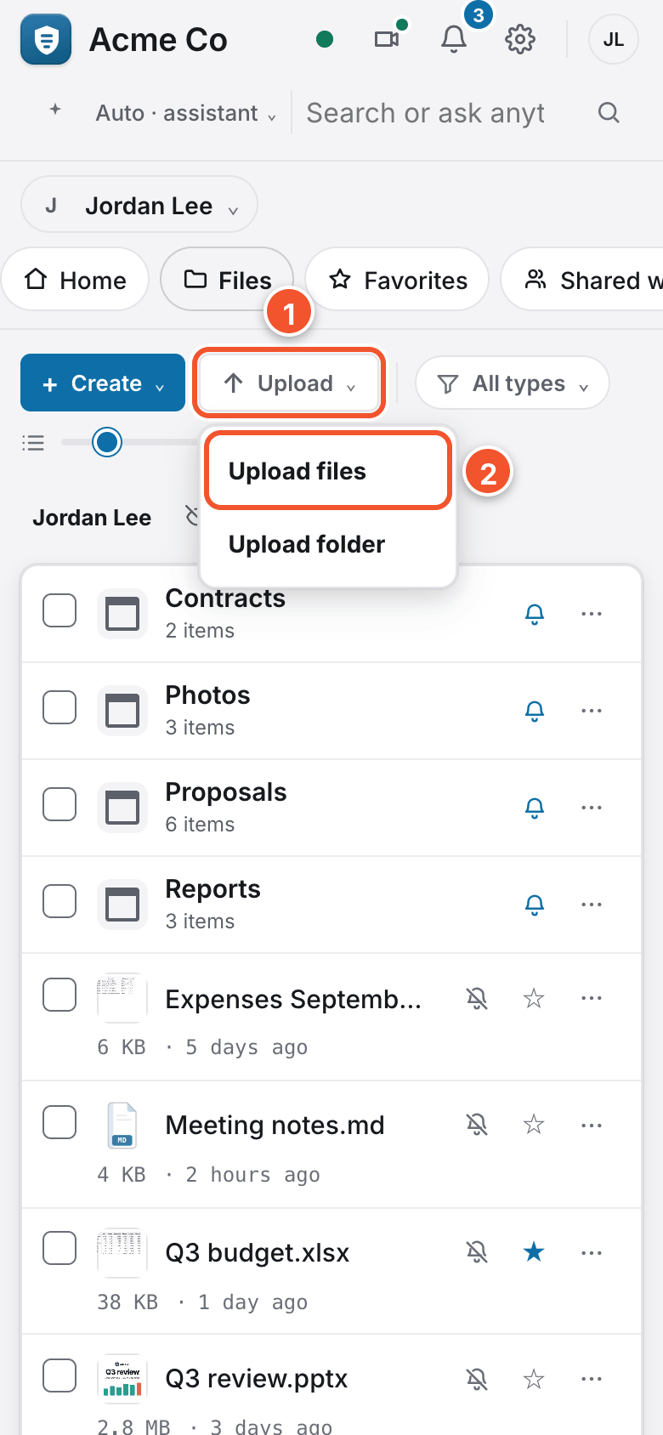 | - Tap Upload.  - Tap Upload files. Your phone then lets you pick a photo, take a new one, or choose a file.

